**Army Institute of Technology**



# Department of Information Technology

LAB Manual

**Laboratory Practice-I (Machine Learning)**

# (Subject Code: 314448)



***Army Institute of Technology***



***CERTIFICATE***

*This is to certify that Mr./Ms. …………………………………………….…...*

*of Class Fourth Year (B.E.) Branch:- …………………..Div:-…………….*

*Roll No…………Exam Seat No ……………………. has completed. All Practical Assignments in the subject* **Laboratory Practice-I (Machine Learning) (Subject Code: 314448)** *satisfactorily* in the department of Information Technology in the *academic year 2022-2023.*

**Subject In-charge HOD Principal**

|  |  |  |
| --- | --- | --- |
| **Program Outcomes** | | |
| **Students are expected to know and be able to–** | | |
| PO1 | Engineering knowledge | An ability to apply knowledge of mathematics, computing, science, engineering and technology. |
| PO2 | Problem analysis | An ability to define a problem and provide a systematic solution with the help of conducting experiments, analyzing the problem and interpreting the data. |
| PO3 | Design / Development of Solutions | An ability to design, implement, and evaluate software or a software /hardware system ,component ,or process to meet desired need switch in realistic constraints. |
| PO4 | Conduct Investigation of Complex Problems | An ability to identify, formulate, and provide essay schematic solutions to complex engineering /Technology problems. |
| PO5 | Modern Tool Usage | An ability to use the techniques, skills, and modern engineering  technology tools, standard processes necessary for practice as a IT professional. |
| PO6 | The Engineer and Society | An ability to apply mathematical foundations, algorithmic principles, and computer science theory in the modeling and design of computer- based systems with necessary constraints and assumptions. |
| PO7 | Environment and Sustainability | An ability to analyze and provide solution for the local and global impact of information technology on individuals, organizations and society. |
| PO8 | Ethics | An ability to understand professional, ethical, legal, security and social issues and responsibilities. |
| PO9 | Individual and Team Work | An ability to function effectively as an individual or as a team member to accomplish a desired goal(s). |
| PO10 | Communication | An ability to engage in life-long learning and continuing |

|  |  |  |
| --- | --- | --- |
|  | Skills | professional development to cope up with fast changes in the technologies /tools with the help of electives, profession along animations and extra- curricular activities. |
| PO11 | Project Management and  Finance | An ability to communicate effectively in engineering community at large by means of effective presentations, report writing, paper publications, demonstrations. |
| PO12 | Life-long Learning | An ability to understand engineering, management, financial aspects, performance, optimizations and time complexity necessary for professional practice. |

Python programming language

# Prerequisites

**Course Objectives**

1. The objective of this course is to provide students with the fundamental elements of machine learning for classification, regression, clustering.
2. Design and evaluate the performance of different machine learning models.

# Course Outcomes

On completion of the course, students will be able to–

CO1: Implement different supervised and unsupervised learning algorithms.

CO2: Evaluate performance of machine learning algorithms for real-world applications.

# Guidelines for Student's Lab Journal

1. Students should submit term work in the form of a handwritten journal based on a specified list of assignments.
2. Practical Examination will be based on the term work.
3. Students are expected to know the theory involved in the experiment.
4. The practical examination should be conducted if and only if the journal of the candidate is complete in all respects.

# Guidelines for Lab /TW Assessment

1. Examiners will assess the term work based on performance of students considering the parameters such as timely conduction of practical assignment, methodology adopted for implementation of practical assignment, timely submission of assignment in the form of handwritten write-up along with results of implemented assignment, attendance etc.
2. Examiners will judge the understanding of the practical performed in the examination by asking some questions related to theory & implementation of experiments he/she has carried out.
3. Appropriate knowledge of usage of software and hardware related to respective laboratories should be as a conscious effort and little contribution towards Green IT and environment awareness, attaching printed papers of the program in a journal may be avoided. There must be hand-written write-ups for every assignment in the journal. The DVD/CD containing student programs should be attached to the journal by every student and the same to be maintained by the department/lab In-charge is highly encouraged. For reference one or two journals may be maintained with program prints at Laboratory.

# Guidelines for Laboratory Conduction

1. All the assignments should be implemented using python programming language
2. Implement any 4 assignments out of 6
3. Assignment clustering with K-Means is compulsory
4. The instructor is expected to frame the assignments by understanding the prerequisites, technological aspects, utility and recent trends related to the topic.
5. The instructor may frame multiple sets of assignments and distribute them among batches of students.
6. All the assignments should be conducted on multicore hardware and 64-bit open-sources software

# Guidelines for Practical Examination

1. Both internal and external examiners should jointly set problem statements for practical examination. During practical assessment, the expert evaluator should give the maximum Weightage to the satisfactory implementation of the problem statement.
2. The supplementary and relevant questions may be asked at the time of evaluation to judge the student ‘s understanding of the fundamentals, effective and efficient implementation.
3. The evaluation should be done by both external and internal examiners.

# List of Laboratory Assignments

|  |  |
| --- | --- |
| **Sr.No.** | **Statement of Assignment** |
| 1 | **Data preparation:**  Download heart dataset from following link. https://[www.kaggle.com/zhaoyingzhu/heartcsv](http://www.kaggle.com/zhaoyingzhu/heartcsv) Perform following operation on given dataset.   1. Find Shape of Data 2. Find Missing Values 3. Find data type of each column 4. Finding out Zero's 5. Find Mean age of patients 6. Now extract only Age, Sex, ChestPain, RestBP, Chol. Randomly divide dataset in training (75%) and testing (25%).   Through the diagnosis test I predicted 100 report as COVID positive, but only 45 of those were actually positive. Total 50 people in my sample were actually COVID positive. I have total 500 samples.  Create confusion matrix based on above data and find   1. Accuracy 2. Precision 3. Recall 4. F-1 score |
| 2 | **Assignment on Regression Technique:**  Download any freely available suitable dataset and perform following steps   1. Apply Linear Regression using suitable library function and perform the prediction for unseen dataset. 2. Assess the performance of regression models using MSE, MAE and R-Square metrics 3. Visualize simple regression model. |
| 3 | **Assignment on Classification Technique:**  Every year many students give the GRE exam to get admission in foreign Universities. The data set contains GRE Scores (out of 340), TOEFL Scores (out of 120), University Rating (out of 5), Statement of Purpose strength (out of 5), Letter of Recommendation strength (out of 5), Undergraduate GPA (out of 10), Research Experience (0=no, 1=yes), Admitted (0=no, 1=yes). Admitted is the target variable.  Data Set Available on kaggle (The last column of the dataset needs to be changed to 0 or |

|  |  |
| --- | --- |
|  | 1)Data Set : https://[www.kaggle.com/mohansacharya/graduate-admissions](http://www.kaggle.com/mohansacharya/graduate-admissions)  The counselor of the firm is supposed check whether the student will get an admission or not based on his/her GRE score and Academic Score. So to help the counselor to take appropriate decisions build a machine learning model classifier using Decision tree to predict whether a student will get admission or not. Apply Data pre-processing (Label Encoding, Data Transformation) techniques if necessary.  Perform data-preparation (Train-Test Split)  A. Apply Machine Learning Algorithm  B. Evaluate Model. |
| 4 | **Assignment on Clustering Techniques**  Download the following customer dataset from below link:  Data Set: https://[www.kaggle.com/shwetabh123/mall-customers](http://www.kaggle.com/shwetabh123/mall-customers)  This dataset gives the data of Income and money spent by the customers visiting a Shopping Mall. The data set contains Customer ID, Gender, Age, Annual Income, Spending Score. Therefore, as a mall owner you need to find the group of people who are the profitable customers for the mall owner. Apply at least two clustering algorithms (based on Spending Score) to find the group of customers.   1. Apply Data pre-processing (Label Encoding , Data Transformation....) techniques if necessary. 2. Perform data-preparation( Train-Test Split) 3. Apply Machine Learning Algorithm 4. Evaluate Model. 5. Apply Cross-Validation and Evaluate Model |
| 5 | **Assignment on Association Rule Learning**  Download Market Basket Optimization dataset from below link.  Data Set: https://[www.kaggle.com/hemanthkumar05/market-basket-optimization](http://www.kaggle.com/hemanthkumar05/market-basket-optimization)  This dataset comprises the list of transactions of a retail company over the period of one week. It contains a total of 7501 transaction records where each record consists of the list of items sold in one transaction. Using this record of transactions and items in each transaction, find the association rules between items. There is no header in the dataset and the first row contains the first transaction, so mentioned header = None here while loading dataset.   1. Follow following steps: 2. Data Preprocessing 3. Generate the list of transactions from the dataset 4. Train Apriori algorithm on the dataset 5. Visualize the list of rules   F. Generated rules depend on the values of hyper parameters. By increasing the minimum confidence value and find the rules accordingly |
| 6 | **Assignment on Artificial Neural Network** |

|  |  |
| --- | --- |
|  | Download the dataset of National Institute of Diabetes and Digestive and Kidney Diseases from below link :  DataSet: https://raw.githubusercontent.com/jbrownlee/Datasets/master/pima-indians- diabetes.data.csv  The dataset is has total 9 attributes where the last attribute is “Class attribute” having values 0 and 1. (1=”Positive for Diabetes”, 0=”Negative”)   1. Load the dataset in the program. Define the ANN Model with Keras. Define at least two hidden layers. Specify the ReLU function as activation function for the hidden layer and Sigmoid for the output layer. 2. Compile the model with necessary parameters. Set the number of epochs and batch size and fit the model. 3. Evaluate the performance of the model for different values of epochs and batch sizes. 4. Evaluate model performance using different activation functions Visualize the model using ANN Visualizer. |

**Assignment No. 1**

**Title:** Data Preparation

# Problem Statement:

Download heart dataset from the following link. https://[www.kaggle.com/zhaoyingzhu/heartcsv](http://www.kaggle.com/zhaoyingzhu/heartcsv) Perform the following operation on a given dataset.

1. Find Shape of Data
2. Find Missing Values
3. Find data type of each column
4. Finding out Zero's
5. Find Mean age of patients
6. Now extract only Age, Sex, ChestPain, RestBP, Chol. Randomly divide the dataset in training (75%) and testing (25%).

# Objectives:

Data preparation is particular to data, the objectives of the projects, and the algorithms that will be used in data modeling techniques. Data Preparation is the process of cleaning and transforming raw data to make predictions accurately through using ML algorithms. Each predictive modeling project with machine learning is different, but there are common steps performed on each project.

# Theory:

## What is Data Preparation

On a predictive modeling project, such as classification or regression, raw data typically cannot be used directly. Data can not be directly used as it might have impurities some which will act as a barrier in further processes. So hence we can define that data preparation is one of the important steps in the data science domain, in which data collected from multiple sources is cleaned and transformed to improve its quality prior to use in business analytics. Having quality data makes administration fast.

Data Preparation is the first step in data analytics projects and can include many tasks such as loading data, data ingestion,fusion,cleaning augmentation and delivery.

As such, the raw data must be pre-processed prior to being used to fit and evaluate a machine learning model. This step in a predictive modeling project is referred to as “**data preparation**“, although it goes by many other names, such as “*data wrangling*“, “*data cleaning*“, “*data pre- processing*” and “*feature engineering*“. Some of these names may better fit as sub-tasks for the broader data preparation process.

We can define data preparation as the transformation of raw data into a form that is more suitable for modeling.

These tasks include:

* **Data Cleaning**: Identifying and correcting mistakes or errors in the data.
* **Feature Selection**: Identifying those input variables that are most relevant to the task.
* **Data Transforms**: Changing the scale or distribution of variables.
* **Feature Engineering**: Deriving new variables from available data.
* **Dimensionality Reduction**: Creating compact projections of the data. Each of these tasks is a whole field of study with specialized algorithms.

## Why do we need Data Preprocessing?

A real-world data generally contains noises, missing values, and maybe in an unusable format which cannot be directly used for machine learning models. Data preprocessing is required for cleaning the data and making it suitable for a machine learning model which also increases the accuracy and efficiency of a machine learning model.

It involves below steps:

* 1. Getting the dataset
  2. Importing libraries
  3. Importing datasets
  4. Finding Missing Data
  5. Encoding Categorical Data
  6. Splitting dataset into training and test set
  7. Feature scaling

## Get the Dataset

To create a machine learning model, the first thing we required is a dataset as a machine learning model completely works on data. The collected data for a particular problem in a proper format is known as the **dataset**.

Dataset may be of different formats for different purposes, such as, if we want to create a machine learning model for business purpose, then dataset will be different with the dataset required for a liver patient. So each dataset is different from another dataset. To use the dataset in our code, we usually put it into a CSV **file**. However, sometimes, we may also need to use an HTML or xlsx file.

## .CSV File

CSV stands for "**Comma-Separated Values**" files; it is a file format which allows us to save the tabular data, such as spreadsheets. It is useful for huge datasets and can use these datasets in programs.

For real-world problems, we can download datasets online from various sources such as https://[www.kaggle.com/zhaoyingzhu/heartcsv](http://www.kaggle.com/zhaoyingzhu/heartcsv)

We can also create our dataset by gathering data using various API with Python and put that data into a **.csv** file.

## Importing Libraries

In order to perform data preprocessing using Python, we need to import some predefined Python libraries. These libraries are used to perform some specific jobs. There are three specific libraries that we will use for data preprocessing, which are:

**Numpy:** Numpy Python library is used for including any type of mathematical operation in the code. It is the fundamental package for scientific calculation in Python. It also supports to add large, multidimensional arrays and matrices. So, in Python, we can import it as:

## import numpy as nm

Here we have used **nm**, which is a short name for Numpy, and it will be used in the whole program.

**Matplotlib:** The second library is **matplotlib**, which is a Python 2D plotting library, and with this library, we need to import a sub-library **pyplot**. This library is used to plot any type of charts in Python for the code. It will be imported as below:

## import matplotlib.pyplot as mpt

Here we have used mpt as a short name for this library.

**Pandas:** The last library is the Pandas library, which is one of the most famous Python libraries and used for importing and managing the datasets. It is an open-source data manipulation and analysis library. It will be imported as below:

Here, we have used pd as a short name for this library. Consider the below image:

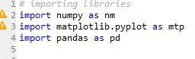

## Importing the Datasets

Now we need to import the datasets which we have collected for our machine learning project. But before importing a dataset, we need to set the current directory as a working directory. To set a working directory in Spyder IDE, we need to follow the below steps:

* 1. Save your Python file in the directory which contains dataset.
  2. Go to File explorer option in Spyder IDE, and select the required directory.
  3. Click on F5 button or run option to execute the file.

## Confusion Matrix:

It is matrix of size 2*2 matrix used to describe the performance of a classification model with actual values on one axis and predicted on another.

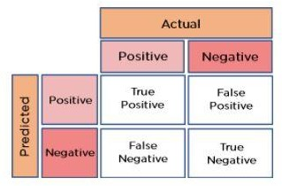

Confusion matrix not only shows performance of predictive model, but also which classes are being predicted correctly and incorrectly and what type of errors are being made

**True Positive :** model predicted positive and its’s true

**True Negative:** model predicted negative and it’s true i.e. negative in reality.

**False Positive:** model predicted positive and it’s false **False Negative:** model predicted negative and it’s false The rate of confusion matrix are as follows

True Positive Rate(TPR), False Negative Rate(FNR), True Negative Rate(TNR), False Positive Rate(FPR),

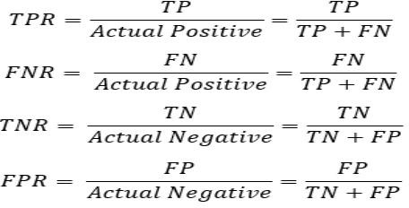

## Need for Confusion Matrix in Machine learning

* It evaluates the performance of the classification models, when they make predictions on test data, and tells how good our classification model is.
* It not only tells the error made by the classifiers but also the type of errors such as it is either type-I or type-II error.
* With the help of the confusion matrix, we can calculate the different parameters for the model, such as accuracy, precision, etc.

## Calculations using Confusion Matrix:

We can perform various calculations for the model, such as the model's accuracy, using this matrix. These calculations are given below:

* **Classification Accuracy:** It is one of the important parameters to determine the accuracy of the classification problems. It defines how often the model predicts the correct output. It can be calculated as the ratio of the number of correct predictions made by the

classifier to all number of predictions made by the classifiers. The formula is given below:



* **Misclassification rate:** It is also termed as Error rate, and it defines how often the model gives the wrong predictions. The value of error rate can be calculated as the number of incorrect predictions to all numbers of the predictions made by the classifier. The formula

is given below:



* **Precision:** It can be defined as the number of correct outputs provided by the model or out of all positive classes that have predicted correctly by the model, how many of them were actually true. It can be calculated using the below formula:



* **Recall:** It is defined as the out of total positive classes, how our model predicted correctly.



The

recall

must

be

as

high

as

possible.

* **F-measure:** If two models have low precision and high recall or vice versa, it is difficult to compare these models. So, for this purpose, we can use F-score. This score helps us to evaluate the recall and precision at the same time. The F-score is maximum if the recall is

equal to the precision. It can be calculated using the below formula:



## Other important terms used in Confusion Matrix:

* **Null Error rate:** It defines how often our model would be incorrect if it always predicted the majority class. As per the accuracy paradox, it is said that "*the best classifier has a higher error rate than the null error rate.*"
* **ROC Curve:** The ROC is a graph displaying a classifier's performance for all possible thresholds. The graph is plotted between the true positive rate (on the Y-axis) and the false Positive rate (on the x-axis).

# Conclusion:

Most machine learning algorithms require data to be formatted in a very specific way, so datasets generally require some amount of preparation before they can yield useful insights.

# Questions:

1. What are the 5 major steps of data preprocessing?
2. Why is data preprocessing required?
3. What are the different techniques for data preprocessing in machine learning?
4. What is the use of a confusion matrix in machine learning?
5. How do you calculate precision and recall from confusion matrix
6. How can you calculate accuracy using a confusion matrix?

# Assignment No. 2

**Title:** Regression Technique

# Problem statement:

Download any freely available suitable dataset and perform the following steps to build regression model.

1. Apply Linear Regression using a suitable library function and perform prediction for test data.
2. Assess the performance of regression models using MSE, MAE and R-Square metrics
3. Visualize a simple regression model.

**Objectives:** In order to predict the value of the dependent variable for individuals for whom some information concerning the explanatory variables is available, or in order to estimate the effect of some explanatory variable on the dependent variable.Estimate the relationship between explanatory and response variable. Determine the effect of each of the explanatory variables on the response variable. Predict the value of the response variable for a given value of explanatory variable

# Theory:

## Introduction to Regression

Regression is another important and broadly used statistical and machine learning tool. The key objective of regression-based tasks is to predict output labels or responses which are continuous numeric values, for the given input data. The output will be based on what the model has learned in the training phase. Basically, regression models use the input data features (independent variables) and their corresponding continuous numeric output values (dependent or outcome variables) to learn specific association between inputs and corresponding outputs.

## Linear Regression

Linear regression analysis is used to predict the value of a variable based on the value of another variable. The variable we want to predict is called a dependent variable and the variable we used to predict is called an independent variable.

Linear regression was developed in field of statistics and is studied as model for understanding relationships between input and output variables

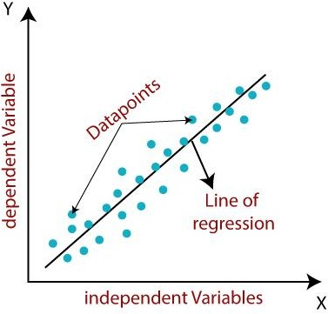

## Types of Linear Regression Model

Linear regression can be further divided into two types of the algorithm:

* 1. Simple linear regression
  2. Multiple linear regression

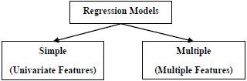

**Simple linear regression** − Simple linear algorithms have one dependent and independent variable; their relationship is a deterministic relationship if one variable can be expressed accurately by another. The main idea is to draw a line that best fits data i.e. all predicted points should lie on the best fit line. Error is distance between point and regression line Regression analysis is used to find equation that fits the data

The Simple Linear Regression model can be represented using the below equation: equation has form of y= a0+a1x+ ε

Where,

a0= It is the intercept of the Regression line (can be obtained putting x=0)

a1= It is the slope of the regression line, which tells whether the line is increasing or decreasing. ε = The error term. (For a good model it will be negligible)

## Implementation of Simple Linear Regression Algorithm using Python

Problem Statement example for Simple Linear Regression:

Here we are taking a dataset that has two variables: salary (dependent variable) and experience (Independent variable). The goals of this problem is:

* We want to find out if there is any correlation between these two variables
* We will find the best fit line for the dataset.
* How the dependent variable is changing by changing the independent variable.

In this section, we will create a Simple Linear Regression model to find out the best fitting line for representing the relationship between these two variables.first step in finding Linear Regression equation.

**Multiple linear regression** − In this type of linear regression, we always attempt to discover the relationship between two or more independent variables or input and corresponding dependent variable or output. Multiple Linear Regression is one of the important regression algorithms which models the linear relationship between a single dependent continuous variable and more than one independent variable.

Some key points about MLR:

* For MLR, the dependent or target variable(Y) must be the continuous/real, but the predictor or independent variable may be of continuous or categorical form.
* Each feature variable must model the linear relationship with the dependent variable.
* MLR tries to fit a regression line through a multidimensional space of data-points.

## MLR equation:

In Multiple Linear Regression, the target variable(Y) is a linear combination of multiple predictor variables x1, x2, x3, ...,xn. Since it is an enhancement of Simple Linear Regression, so the same is applied for the multiple linear regression equation, the equation becomes:

Y= b0+b1x1+ b2x2+ b3x3+...... bnxn (a)

Where,

Y= Output/Response variable

b0, b1, b2, b3 , bn = Coefficients of the model.

x1, x2, x3, x4, = Various Independent/feature variable

## Assumptions for Multiple Linear Regression:

* A linear relationship should exist between the Target and predictor variables.
* The regression residuals must be normally distributed.
* MLR assumes little or no multicollinearity (correlation between the independent variable) in data.

## Implementation of Multiple Linear Regression model using Python:

To implement MLR using Python, we have below problem:

MLR is the dependent variable, and the other four variables are independent variables. Below are the main steps of deploying the MLR model:

1. Data Pre-processing Steps
2. Fitting the MLR model to the training set
3. Predicting the result of the test setApplications

## The applications of ML regression algorithms are as follows −

* Forecasting or Predictive analysis
* Optimization
* Error correction
* Economics
* Finance
* Effectiveness of Independent variable on prediction:
* Predicting the impact of changes:

## Evaluation Metrics in Regression Techniques

To understand the benefits and disadvantages of Evaluation metrics because different evaluation metrics fits on a different set of a dataset.

Now, I hope you get the importance of Evaluation metrics. Let's start understanding various evaluation metrics used for regression tasks.

In machine learning our main goal is to minimize the error which is defined by loss function. There are various loss functions like regression loss function, Mean Square Error, Mean Absolute Error.

## Mean Absolute Error(MAE)

MAE is a very simple metric which calculates the absolute difference between actual and predicted values.

The MAE of your model which is basically a mistake made by the model known as an error. Now find the difference between the actual value and predicted value that is an absolute error but we have to find the mean absolute of the complete dataset.

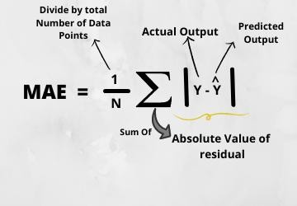so, sum all the errors and divide them by a total number of observations.

from sklearn.metrics import mean_absolute_error print("MAE",mean_absolute_error(y_test,y_pred)) **Advantages of MAE**

* + The MAE you get is in the same unit as the output variable.
  + It is most Robust to outliers.

## Disadvantages of MAE

* + The graph of MAE is not differentiable so we have to apply various optimizers like Gradient descent which can be differentiable.

## Mean Squared Error(MSE)

MSE is a most used and very simple metric with a little bit of change in mean absolute error. Mean squared error states that finding the squared difference between actual and predicted value. It represents the squared distance between actual and predicted values. We perform squared to avoid the cancellation of negative terms and it is the benefit of MSE.

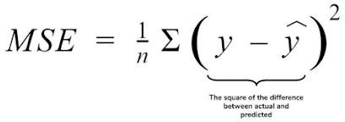

from sklearn.metrics import mean_squared_error print("MSE",mean_squared_error(y_test,y_pred))

## Advantages of MSE

The graph of MSE is differentiable, so you can easily use it as a loss function.

## Disadvantages of MSE

* + The value you get after calculating MSE is a squared unit of output. for example, the output variable is in meter(m) then after calculating MSE the output we get is in meter squared.
  + If you have outliers in the dataset then it penalizes the outliers most and the calculated MSE is bigger. So, in short, It is not Robust to outliers which were an advantage in MAE.

1. Root Mean Squared Error(RMSE)

As RMSE is clear by the name itself, that it is a simple square root of mean squared error.

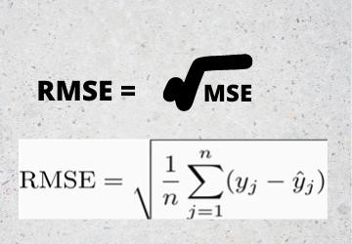

for performing RMSE we have to NumPy NumPy square root function over MSE. print("RMSE",np.sqrt(mean_squared_error(y_test,y_pred)))

## Advantages of RMSE

* + The output value you get is in the same unit as the required output variable which makes interpretation of loss easy.

## Disadvantages of RMSE

* + It is not that robust to outliers as compared to MAE.

Most of the time people use RMSE as an evaluation metric and mostly when you are working with deep learning techniques the most preferred metric is RMSE.

## Root Mean Squared Log Error(RMSLE)

Taking the log of the RMSE metric slows down the scale of error. The metric is very helpful when you are developing a model without calling the inputs. In that case, the output will vary on a large scale.

To control this situation of RMSE we take the log of calculated RMSE error and resultant we get as RMSLE.

To perform RMSLE we have to use the NumPy log function over RMSE.

print("RMSE",np.log(np.sqrt(mean_squared_error(y_test,y_pred))))

It is a very simple metric that is used by most of the datasets hosted for Machine Learning competitions.

## R Squared (R2)

R2 score is a metric that tells the performance of your model, not the loss in an absolute sense that how many wells did your model perform.

In contrast, MAE and MSE depend on the context as we have seen whereas the R2 score is independent of context.

So, with help of R squared we have a baseline model to compare a model which none of the other metrics provides. The same we have in classification problems which we call a threshold which is fixed at 0.5. So basically R2 squared calculates how the regression line is better than a mean line.

Hence, R2 squared is also known as Coefficient of Determination or sometimes also known as Goodness of fit.

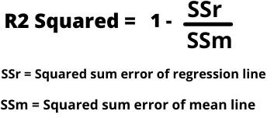

*R2 Squared*

Value of R2 can be even negative when the model fitted is worse than the average fitted model.

from sklearn.metrics import r2_score r2 = r2_score(y_test,y_pred) print(r2)

## Adjusted R Squared

The disadvantage of the R2 score is while adding new features in data the R2 score starts increasing or remains constant but it never decreases because It assumes that while adding more data variance of data increases.

Hence, To control this situation Adjusted R Squared came into existence.

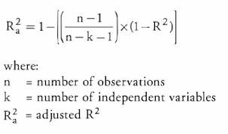

Now as K increases by adding some features so the denominator will decrease, n-1 will remain constant. R2 score will remain constant or will increase slightly so the complete answer will increase and when we subtract this from one then the resultant score will decrease. so this is the case when we add an irrelevant feature in the dataset.

And if we add a relevant feature then the R2 score will increase and 1-R2 will decrease heavily and the denominator will also decrease so the complete term decreases, and on subtracting from one the score increases.

n=40

k=2

adj_r2_score = 1 - ((1-r2)*(n-1)/(n-k-1))

p

**Conclusion:** The system integrates the task of developing a regression model from data, with the technique of searching for logical conditions that enable a better fitting error by the model.It continues to be a significant asset to many leading sectors starting from finance, education, banking, retail, medicine, media, etc.

# Questions:

1. What is Regression?
2. What is a dependent variable
3. What are independent variables?
4. What is linear regression?
5. Which model is used for regression?
6. Which of the following metrics can be used for evaluating regression models?
7. What methods are used for the evaluation of regression models?

# Assignment No. 3

**Title:** Classification Technique

# Problem Statement:

Data Set Available on kaggle (The last column of the dataset needs to be changed to 0 or 1)Data Set : https://[www.kaggle.com/mohansacharya/graduate-admissions](http://www.kaggle.com/mohansacharya/graduate-admissions) The counselor of the firm is supposed check whether the student will get an admission or not based on his/her GRE score and Academic Score. So to help the counselor to make appropriate decisions, build a machine learning model classifier using a Decision tree to predict whether a student will get admission or not.

1. Apply Data pre-processing (Label Encoding, Data Transformation….) techniques if necessary.
2. Perform data-preparation (Train-Test Split)
3. Apply Machine Learning Algorithm
4. Evaluate Model. 4

# Objective:

The main goal of the Classification algorithm is to identify the category of a given dataset, and these algorithms are mainly used to predict the output for the categorical data.

# Theory:

## Classification Algorithm

The Classification algorithm is a Supervised Learning technique that is used to identify the category of new observations on the basis of training data.

In the classification algorithm, a discrete output function(y) is mapped to input variable(x). y=f(x), where y = categorical output

The best example of an ML classification algorithm is Email Spam Detector.

The main goal of the Classification algorithm is to identify the category of a given dataset, and these algorithms are mainly used to predict the output for the categorical data.

Classification algorithms can be better understood using the below diagram. In the below diagram, there are two classes, class A and Class B. These classes have features that are similar to each other and dissimilar to other classes.

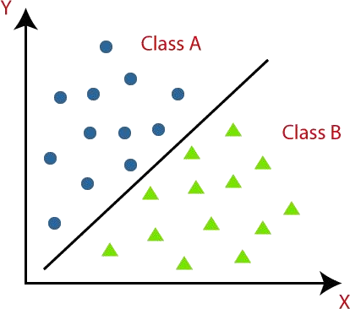

## Types of ML Classification Algorithms:

Classification Algorithms can be further divided into the Mainly two category:

* Linear Models
  + Logistic Regression
  + Support Vector Machines
* Non-linear Models
  + K-Nearest Neighbors
  + Kernel SVM
  + Naïve Bayes
  + Decision Tree Classification
  + Random Forest Classification

## Decision Tree Classification Algorithm

Decision Tree is a Supervised learning technique that can be used for both classification and Regression problems, but mostly it is preferred for solving Classification problems. It is a tree- structured classifier, where internal nodes represent the features of a dataset, branches represent the decision rules and each leaf node represents the outcome.

In a Decision tree, there are two nodes, which are the Decision Node and Leaf Node. Decision nodes are used to make any decision and have multiple branches, whereas Leaf nodes are the output of those decisions and do not contain any further branches.

The decisions or the test are performed on the basis of features of the given dataset. It is a graphical representation for getting all the possible solutions to a problem/decision based on given conditions.

It is called a decision tree because, similar to a tree, it starts with the root node, which expands on further branches and constructs a tree-like structure. In order to build a tree, we use the CART algorithm, which stands for Classification and Regression Tree algorithm.

A decision tree simply asks a question, and based on the answer (Yes/No), it further splits the tree into subtrees.

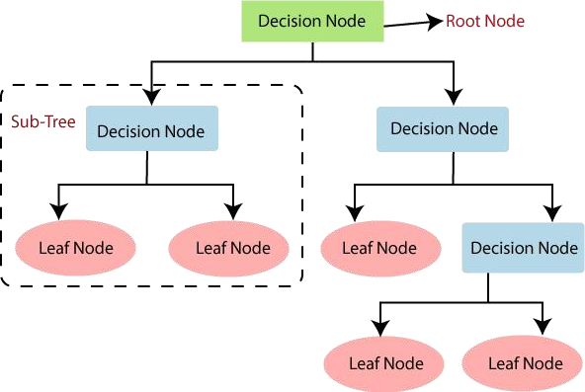Below diagram explains the general structure of a decision tree:

## Decision Trees

There are various algorithms in Machine learning, so choosing the best algorithm for the given dataset and problem is the main point to remember while creating a machine learning model. Below are the two reasons for using the Decision tree:

* Decision Trees usually mimic human thinking ability while making a decision, so it is easy to understand.
* The logic behind the decision tree can be easily understood because it shows a tree-like structure.

## Decision Tree Terminologies

**Root Node:** Root node is from where the decision tree starts. It represents the entire dataset, which further gets divided into two or more homogeneous sets.

**Leaf Node:** Leaf nodes are the final output node, and the tree cannot be segregated further after getting a leaf node.

**Splitting:** Splitting is the process of dividing the decision node/root node into sub-nodes according to the given conditions.

**Branch/Sub Tree:** A tree formed by splitting the tree.

**Pruning:** Pruning is the process of removing the unwanted branches from the tree.

**Parent/Child node:** The root node of the tree is called the parent node, and other nodes are called the child nodes.

## Decision Tree algorithm Work

In a decision tree, for predicting the class of the given dataset, the algorithm starts from the root node of the tree. This algorithm compares the values of the root attribute with the record (real dataset) attribute and, based on the comparison, follows the branch and jumps to the next node.

For the next node, the algorithm again compares the attribute value with the other sub-nodes and moves further. It continues the process until it reaches the leaf node of the tree. The complete process can be better understood using the below algorithm:

* Step-1: Begin the tree with the root node, says S, which contains the complete dataset.
* Step-2: Find the best attribute in the dataset using Attribute Selection Measure (ASM).
* Step-3: Divide the S into subsets that contain possible values for the best attributes.
* Step-4: Generate the decision tree node, which contains the best attribute.
* Step-5: Recursively make new decision trees using the subsets of the dataset created in step -3. Continue this process until a stage is reached where you cannot further classify the nodes and call the final node as a leaf node.

## Attribute Selection Measures

While implementing a Decision tree, the main issue arises that how to select the best attribute for the root node and for sub-nodes. So, to solve such problems there is a technique which is called as Attribute selection measure or ASM. By this measurement, we can easily select the best attribute for the nodes of the tree. There are two popular techniques for ASM, which are:

* Information Gain
* Gini Index

## Information Gain:

* Information gain is the measurement of changes in entropy after the segmentation of a dataset based on an attribute.
* It calculates how much information a feature provides us about a class.
* According to the value of information gain, we split the node and build the decision tree.
* A decision tree algorithm always tries to maximize the value of information gain, and a node/attribute having the highest information gain is split first. It can be calculated using the below formula:

Information Gain= Entropy(S)- [(Weighted Avg) *Entropy(each feature)

**Entropy:** Entropy is a metric to measure the impurity in a given attribute. It specifies randomness in data. Entropy can be calculated as:

Entropy(s)= -P(yes)log2 P(yes)- P(no) log2 P(no) Where,

* S= Total number of samples
* P(yes)= probability of yes
* P(no)= probability of no

## Gini Index:

* Gini index is a measure of impurity or purity used while creating a decision tree in the CART(Classification and Regression Tree) algorithm.
* An attribute with the low Gini index should be preferred as compared to the high Gini index.
* It only creates binary splits, and the CART algorithm uses the Gini index to create binary splits.
* Gini index can be calculated using the below formula:

Gini Index= 1- ∑ P 2

j j

## Pruning: Getting an Optimal Decision tree

Pruning is a process of deleting the unnecessary nodes from a tree in order to get the optimal decision tree.

A too-large tree increases the risk of overfitting, and a small tree may not capture all the important features of the dataset. Therefore, a technique that decreases the size of the learning tree without reducing accuracy is known as Pruning. There are mainly two types of tree pruning technology used:

* Cost Complexity Pruning
* Reduced Error Pruning.

## Advantages of the Decision Tree

* It is simple to understand as it follows the same process which a human follow while making any decision in real-life.
* It can be very useful for solving decision-related problems.
* It helps to think about all the possible outcomes for a problem.
* There is less requirement of data cleaning compared to other algorithms.

## Disadvantages of the Decision Tree

* The decision tree contains lots of layers, which makes it complex.
* It may have an overfitting issue, which can be resolved using the Random Forest algorithm.
* For more class labels, the computational complexity of the decision tree may increase.

## Python Implementation of Decision Tree

Now we will implement the Decision tree using Python. Steps will also remain the same, which are given below:

* Data Preprocessing step
* Fitting a Decision-Tree algorithm to the Training set
* Predicting the test result
* Test accuracy of the result(Creation of Confusion matrix)
* Visualizing the test set result.

**Conclusion:** A Classification is a method of predicting similar information from categorical or numerical datasets. Nowadays machine learning algorithms are becoming more popular for classification problems .It gives an introduction to most of the popular machine learning algorithms used for classification of pattern recognition.

# Questions:

1. What types of Classification Algorithms do you know?
2. What are Decision Trees?
3. What type of node is considered Pure?
4. How are the different nodes of decision trees represented?
5. What are some advantages of using Decision Trees?
6. What is gini index and how is it used in decision tree

# Assignment No. 4

**Title:** Clustering Techniques

# Problem Statement:

Download the following customer dataset from below link: Data Set: https://[www.kaggle.com/shwetabh123/mall-customers](http://www.kaggle.com/shwetabh123/mall-customers)

This dataset gives the data of Income and money spent by the customers visiting a Shopping Mall. The data set contains Customer ID, Gender, Age, Annual Income, Spending Score. Therefore, as a mall owner you need to find the group of people who are the profitable customers for the mall owner. Apply at least two clustering algorithms (based on Spending Score) to find the group of customers.

1. Apply Data pre-processing (Label Encoding , Data Transformation….) techniques if necessary.
2. Perform data-preparation( Train-Test Split)
3. Apply Machine Learning Algorithm
4. Evaluate Model.
5. Apply Cross-Validation and Evaluate Model

# Objective:

The goal of clustering is to find distinct groups or “clusters” within a data set. Using a machine language algorithm, the tool creates groups where items in a similar group will, in general, have similar characteristics to each other.In K-Means, each cluster is associated with a centroid. The main objective of the K-Means algorithm is to minimize the sum of distances between the points and their respective cluster centroid

# Theory:

## Introduction to Clustering

It is basically a type of [unsupervised learning method](https://www.geeksforgeeks.org/supervised-unsupervised-learning/). An unsupervised learning method is a method in which we draw references from datasets consisting of input data without labeled responses. Generally, it is used as a process to find meaningful structure, explanatory underlying processes, generative features, and groupings inherent in a set of examples.

**Clustering** is the task of dividing the population or data points into a number of groups such that data points in the same groups are more similar to other data points in the same group and dissimilar to the data points in other groups. It is basically a collection of objects on the basis of similarity and dissimilarity between them.

The data points in the graph below clustered together can be classified into one single group. We can distinguish the clusters, and we can identify that there are 3 clusters in the below picture.

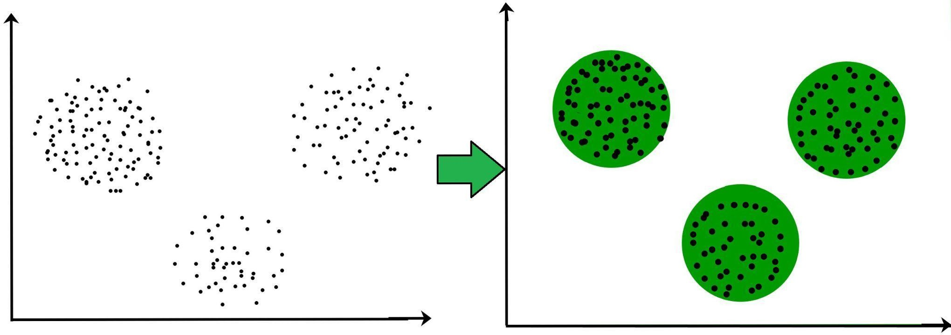

Clustering is very much important as it determines the intrinsic grouping among the unlabelled data present. There are no criteria for good clustering. It depends on the user, what are the criteria they may use which satisfy their need. For instance, we could be interested in finding representatives for homogeneous groups (data reduction), in finding “natural clusters” and describe their unknown properties (“natural” data types), in finding useful and suitable groupings (“useful” data classes) or in finding unusual data objects (outlier detection). This algorithm must make some assumptions that constitute the similarity of points and each assumption makes different and equally valid clusters.

## Clustering Methods :

* **Density-Based Methods:** These methods consider the clusters as the dense region having some similarities and differences from the lower dense region of the space. These methods have good accuracy and the ability to merge two clusters. Example DBSCAN (Density-Based Spatial Clustering of Applications with Noise), OPTICS (Ordering Points to Identify Clustering Structure), etc.
* **Hierarchical Based Methods:** The clusters formed in this method form a tree-type structure based on the hierarchy. New clusters are formed using the previously formed one. It is divided into two category
  + **Agglomerative** (bottom-up approach)
  + **Divisive** (top-down approach)
* **Partitioning Methods:** These methods partition the objects into k clusters and each partition forms one cluster. This method is used to optimize an objective criterion similarity function such as when the distance is a major parameter example K-means, CLARANS (Clustering Large Applications based upon Randomized Search), etc.
* **Grid-based Methods:** In this method, the data space is formulated into a finite number of cells that form a grid-like structure. All the clustering operations done on these grids are fast and independent of the number of data objects, for example STING (Statistical Information Grid), wave cluster, CLIQUE (CLustering In Quest), etc.

## Clustering Workflow

To cluster your data, you'll follow these steps:

* 1. Prepare data.
  2. Create a similarity metric.
  3. Run clustering algorithm.
  4. Interpret results and adjust your clustering.

This page briefly introduces the steps. We'll go into depth in subsequent sections.

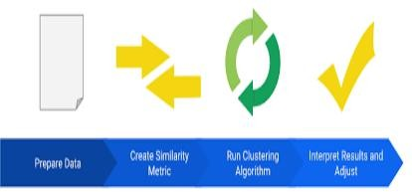

## Prepare Data

As with any ML problem, you must normalize, scale, and transform feature data. While clustering however, you must additionally ensure that the prepared data lets you accurately calculate the similarity between examples. The next sections discuss this consideration.

## Create Similarity Metric

Before a clustering algorithm can group data, it needs to know how similar pairs of examples are. You quantify the similarity between examples by creating a similarity metric. Creating a similarity metric requires you to carefully understand your data and how to derive similarity from your features.

## Run Clustering Algorithm

A clustering algorithm uses the similarity metric to cluster data. This course focuses on k-means.

## Interpret Results and Adjust

Checking the quality of your clustering output is iterative and exploratory because clustering lacks “truth” that can verify the output. You verify the result against expectations at the cluster-

level and the example-level. Improving the result requires iteratively experimenting with the previous steps to see how they affect the clustering.

## Finding K value

We will see 2 methods to find the K value for K-Means.

1. Elbow Method
2. Silhouette Method

## Elbow Method

Elbow Method: This is one of the most popular methods that is used to find K for K-Means.For this, we have to learn something known as WSS(Within the sum of squares).

WSS: The WSS is defined as the sum of squared distance between each member of the cluster and its centroid.

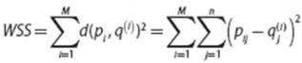

Where p(i)=data point

q(i)=closest centroid to the data point

Here in the elbow method, the K value is chosen after the decrease of WSS is almost constant.

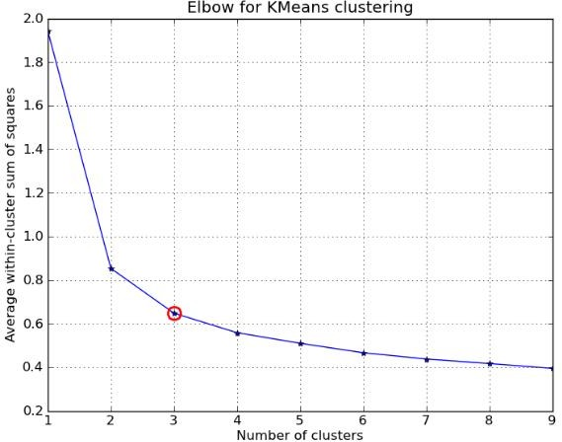

In the above picture, you can see the elbow point, which is 3. After that point, WSS is almost constant. So 3 is selected as K.In this way elbow method is used for finding the value of K

## Silhouette Method

Silhouette Method: Here in the silhouette method, we will compute the silhouette score for every point.

Silhouette Coefficient for the point= (b-a)/max(a,b)

Where

a=mean intra-cluster distance b=mean nearest cluster distance

Silhouette coefficient for dataset = Mean Silhouette Coefficient over points. If we draw a graph for these points, we will get something like this.

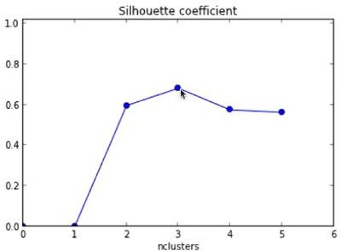

So here we can see the highest silhouette coefficient is for K = 3. In this way, the silhouette method is used for finding K. But in the Silhouette method, there are some chances of getting overfitted to some extent. Because by increasing the number of clusters, the size of clusters becomes small and distance between other clusters may decrease and finally leads to overfitting sometimes. But in a lot of cases, it works well.

It is available in scikit learn library. sklearn.metrics.silhouette_score

## Run the Clustering Algorithm

**K- means Clustering Algorithm :**

K-means clustering is an unsupervised learning algorithm that is used to solve the clustering problems in machine learning or data science. This algorithm groups unabled dataset into different clusters.

The K-means algorithm defines the number of predefined clusters that need to be created in process i.e. for K=2 .There will be two clusters for k=n, there will be ‘n’ clusters. Here the dataset which is divided belongs to only one group that has similar properties.

To cluster data into k clusters, k-means follows the steps below:

**Step One**

The algorithm randomly chooses a centroid for each cluster. In our example, we choose a k of 3, and therefore the algorithm randomly picks 3 centroids.

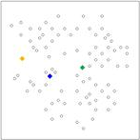

## Figure 1: k-means at initialization

**Step Two**

The algorithm assigns each point to the closest centroid to get k initial clusters.

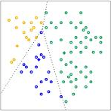

## Figure 2: Initial clusters

**Step Three**

For every cluster, the algorithm recomputes the centroid by taking the average of all points in the cluster. The changes in centroids are shown in Figure 3 by arrows. Since the centroids change, the algorithm then re-assigns the points to the closest centroid. Figure 4 shows the new clusters after reassignment.

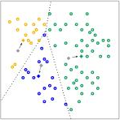

## Figure 3: Recomputation of centroids

**Step Four**

The algorithm repeats the calculation of centroids and assignment of points until points stop changing clusters. When clustering large datasets, you stop the algorithm before reaching convergence, using other criteria instead.

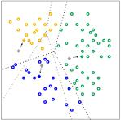

## Figure 4: Clusters after reassignment.

**Interpret Results and Adjust Clustering**

Because clustering is unsupervised, no “truth” is available to verify results. The absence of truth complicates assessing quality. Further, real-world datasets typically do not fall into obvious clusters of examples like the dataset shown in Figure 1.

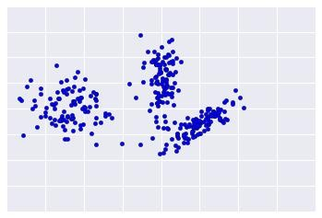

## Figure 1: An ideal data plot; real-world data rarely looks like this.

real-world data looks more like Figure 2, making it difficult to visually assess clustering quality.

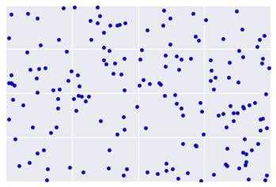

## Figure 2: A true-to-life data plot

The flowchart below summarizes how to check the quality of your clustering. We'll expand upon the summary in the following sections.

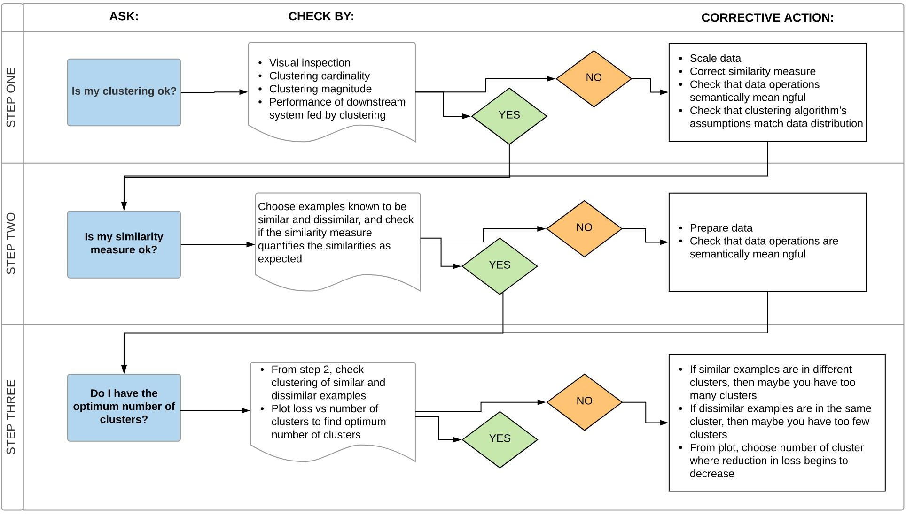

## Step One: Quality of Clustering

Checking the quality of clustering is not a rigorous process because clustering lacks “truth”. Here are guidelines that you can iteratively apply to improve the quality of your clustering.

First, perform a visual check that the clusters look as expected, and that examples that you consider similar do appear in the same cluster. Then check these commonly-used metrics as described in the following sections:

* Cluster cardinality
* Cluster magnitude
* Performance of downstream system

## Cluster cardinality

Cluster cardinality is the number of examples per cluster. Plot the cluster cardinality for all clusters and investigate clusters that are major outliers. For example, in Figure 2, investigate cluster number 5.

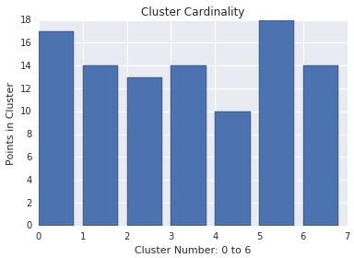

## Figure 2: Cardinality of several clusters

**Cluster magnitude**

Cluster magnitude is the sum of distances from all examples to the centroid of the cluster. Similar to cardinality, check how the magnitude varies across the clusters, and investigate anomalies. For example, in Figure 3, investigate cluster number 0.

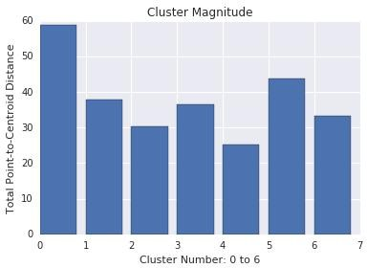

## Figure 3: Magnitude of several clusters

**Magnitude vs. Cardinality**

Notice that a higher cluster cardinality tends to result in a higher cluster magnitude, which intuitively makes sense. Clusters are anomalous when cardinality doesn't correlate with magnitude relative to the other clusters. Find anomalous clusters by plotting magnitude against cardinality. For example, in Figure 4, fitting a line to the cluster metrics shows that cluster number 0 is anomalous.

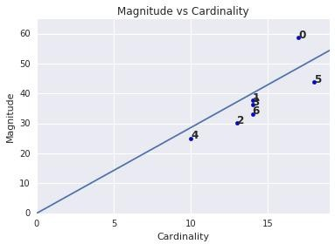

## Figure 4: Cardinality vs. Magnitude of several clusters.

**Performance of Downstream System**

Since clustering output is often used in downstream ML systems, check if the downstream system’s performance improves when your clustering process changes. The impact on your downstream performance provides a real-world test for the quality of your clustering. The disadvantage is that this check is complex to perform.

## Step Two: Performance of the Similarity Measure

Your clustering algorithm is only as good as your similarity measure. Make sure your similarity measure returns sensible results. The simplest check is to identify pairs of examples that are known to be more or less similar than other pairs. Then, calculate the similarity measure for each pair of examples. Ensure that the similarity measure for more similar examples is higher than the similarity measure for less similar examples.

The examples you use to spot check your similarity measure should be representative of the data set. Ensure that your similarity measure holds for all your examples. Careful verification ensures that your similarity measure, whether manual or supervised, is consistent across your dataset. If your similarity measure is inconsistent for some examples, then those examples will not be clustered with similar examples.

## Step Three: Optimum Number of Clusters

k-means requires you to decide the number of clusters k beforehand. How do you determine the optimal value of k. Try running the algorithm for increasing k and note the sum of cluster magnitudes. As k increases, clusters become smaller, and the total distance decreases. Plot this distance against the number of clusters. As shown in Figure 4, at a certain k the reduction in loss becomes marginal with increasing k Mathematically, that's roughly the k where the slope crosses

above -1 (θ>135∘ ). This guideline doesn't pinpoint an exact value for the optimum k but only an approximate value. For the plot shown, the optimum k is approximately 11. If you prefer more granular clusters, then you can choose a higher k using this plot as guidance.

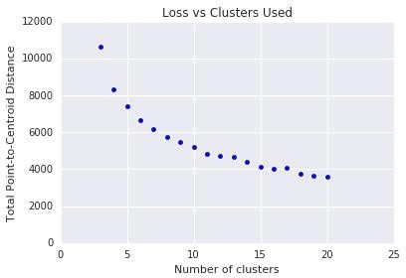

## Figure 4: Loss vs. number of clusters k-Means Advantages and Disadvantages

**Advantages of k-means**

Relatively simple to implement. Scales to large data sets.

Guarantees convergence.

Can warm-start the positions of centroids. Easily adapts to new examples.

Generalizes to clusters of different shapes and sizes, such as elliptical clusters.

## Disadvantages of k-means Choosing k manually.

Use the “Loss vs. Clusters” plot to find the optimal (k)

## Being dependent on initial values.

For a low kyou can mitigate this dependence by running k-means several times with different initial values and picking the best result. As k increases, you need advanced versions of k-means to pick better values of the initial centroids (called k-means seeding).

## Clustering data of varying sizes and density.

k-means has trouble clustering data where clusters are of varying sizes and density.

## Clustering outliers.

Centroids can be dragged by outliers, or outliers might get their own cluster instead of being ignored. Consider removing or clipping outliers before clustering.

**Scaling with a number of dimensions.**

# Conclusion:

We have learned about the K Means clustering algorithm from scratch to implementation. First, we have seen clustering and then finding K value in K Means. For that, we have seen two different methods. Overall we have seen the importance of the K Means clustering algorithm. Finally, we had implemented the code for this algorithm in the Jupyter notebook.

# Questions:

1. What is clustering?
2. Where is clustering used in real life?
3. When to use k-means vs K medians?
4. Which methods belong to clustering?
5. What is the difference between classification and clustering?
6. Which clustering algorithm is best?
7. Which algorithm is used by clustering in machine learning?

# Assignment No.5

**Title:** Association Rule Learning

## Problem Statement:

Download Market Basket Optimization dataset from below link.

Data Set: https://[www.kaggle.com/hemanthkumar05/market-basket-optimization](http://www.kaggle.com/hemanthkumar05/market-basket-optimization)

This dataset comprises the list of transactions of a retail company over the period of one week. It contains a total of 7501 transaction records where each record consists of the list of items sold in one transaction. Using this record of transactions and items in each transaction, find the association rules between items.

There is no header in the dataset and the first row contains the first transaction, so mentioned header = None here while loading dataset.

1. Follow following steps:
2. Data Preprocessing
3. Generate the list of transactions from the dataset
4. Train Apriori algorithm on the dataset
5. Visualize the list of rules

F. Generated rules depend on the values of hyper parameters. By increasing the minimum confidence value and find the rules accordingly

# Objective:

Association rule learning is a rule-based machine learning method for discovering interesting relations between variables in large databases. It is intended to identify strong rules discovered in databases using some measures of interestingness.

# Theory:

## Association Rule Learning

Association rule learning is a type of unsupervised learning technique that checks for the dependency of one data item on another data item and maps accordingly so that it can be more profitable. It tries to find some interesting relations or associations among the variables of the dataset. It is based on different rules to discover the interesting relations between variables in the database.

The association rule learning is one of the very important concepts of [machine learning](https://www.javatpoint.com/machine-learning), and it is employed in Market Basket analysis, Web usage mining, continuous production, etc. Here market basket analysis is a technique used by the various big retailers to discover the associations between items. We can understand it by taking an example of a supermarket, as in a supermarket, all products that are purchased together are put together.

For example, if a customer buys bread, he most likely can also buy butter, eggs, or milk, so these products are stored within a shelf or mostly nearby. Consider the below diagram:

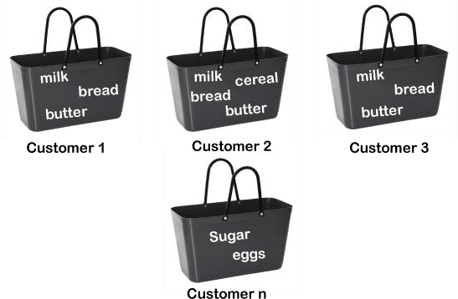

## How does Association Rule Learning work?

Association rule learning works on the concept of If and Else Statement, such as if A then B.

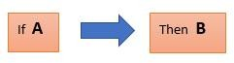

Here the If element is called antecedent, and then the statement is called as Consequent. These types of relationships where we can find out some association or correlation between two items is known *as single cardinality*. It is all about creating rules, and if the number of items increases, then cardinality also increases accordingly. So, to measure the associations between thousands of data items, there are several metrics. These metrics are given below:

* Support
* Confidence
* Lift

## Support

Support is the frequency of A or how frequently an item appears in the dataset. It is defined as the fraction of the transaction T that contains the itemset X. If there are X datasets, then for transactions T, it can be written as:



## Confidence

Confidence indicates how often the rule has been found to be true. Or how often the items X and Y occur together in the dataset when the occurrence of X is already given. It is the ratio of the transaction that contains X and Y to the number of records that contain X.



## Lift

It is the strength of any rule, which can be defined as below formula:



It is the ratio of the observed support measure and expected support if X and Y are independent of each other. It has three possible values:

* If Lift= 1: The probability of occurrence of antecedent and consequent is independent of each other.
* Lift>1: It determines the degree to which the two itemsets are dependent on each other.
* Lift<1: It tells us that one item is a substitute for other items, which means one item has a negative effect on another.

## Types of Association Rule Learning

Association rule learning can be divided into three algorithms:

1. Apriori
2. Eclat
3. F-P Growth Algorithm

## Apriori Algorithm

This algorithm uses frequent datasets to generate association rules. It is designed to work on the databases that contain transactions. This algorithm uses a breadth-first search and Hash Tree to calculate the itemset efficiently. It is mainly used for market basket analysis and helps to understand the products that can be bought together. It can also be used in the healthcare field to find drug reactions for patients.

The Apriori algorithm uses frequent itemsets to generate association rules, and it is designed to work on the databases that contain transactions. With the help of these association rules, it determines how strongly or how weakly two objects are connected. This algorithm uses a breadth-first search and Hash Tree to calculate the itemset associations efficiently. It is the iterative process for finding the frequent itemsets from the large dataset.

## What is a Frequent Itemset?

Frequent itemsets are those items whose support is greater than the threshold value or user- specified minimum support. It means if A & B are the frequent itemsets together, then individually A and B should also be the frequent itemset.

Suppose there are the two transactions: A= {1,2,3,4,5}, and B= {2,3,7}, in these two transactions, 2 and 3 are the frequent item sets.

## Steps for Apriori Algorithm

Below are the steps for the apriori algorithm:

**Step-1:** Determine the support of itemsets in the transactional database, and select the minimum support and confidence.

**Step-2:** Take all supports in the transaction with higher support value than the minimum or selected support value.

**Step-3:** Find all the rules of these subsets that have higher confidence value than the threshold or minimum confidence.

**Step-4:** Sort the rules as the decreasing order of lift.

## Apriori Algorithm Working

We will understand the apriori algorithm using an example and mathematical calculation: Example: Suppose we have the following dataset that has various transactions, and from this dataset, we need to find the frequent itemsets and generate the association rules using the Apriori algorithm:

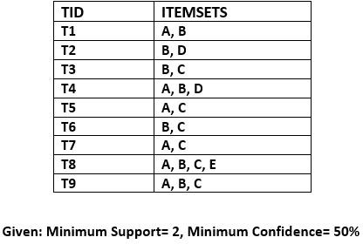

## Solution:

**Step-1: Calculating C1 and L1:**

* In the first step, we will create a table that contains the support count (The frequency of each itemset individually in the dataset) of each itemset in the given dataset. This table is called the Candidate set or C1.

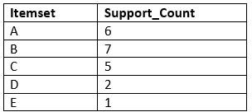

Now, we will take out all the itemsets that have the greater support count than the Minimum Support (2). It will give us the table for the frequent itemset L1.

Since all the itemsets have greater or equal support count than the minimum support, except the E, so E itemset will be removed.

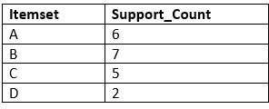

## Step-2: Candidate Generation C2, and L2:

* In this step, we will generate C2 with the help of L1. In C2, we will create the pair of the itemsets of L1 in the form of subsets.
* After creating the subsets, we will again find the support count from the main transaction table of datasets, i.e., how many times these pairs have occurred together in the given dataset. So, we will get the below table for C2:

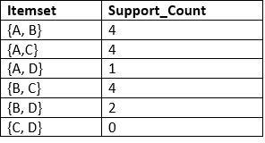

Again, we need to compare the C2 Support count with the minimum support count, and after comparing, the itemset with less support count will be eliminated from the table C2. It will give us the below table for L2

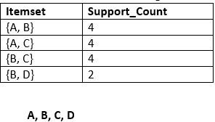

## Step-3: Candidate generation C3, and L3:

* For C3, we will repeat the same two processes, but now we will form the C3 table with subsets of three itemsets together, and will calculate the support count from the dataset. It will give the below table:

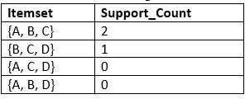

* Now we will create the L3 table. As we can see from the above C3 table, there is only one combination of itemset that has support count equal to the minimum support count. So, the L3 will have only one combination, i.e., {A, B, C}.

## Step-4: Finding the association rules for the subsets:

To generate the association rules, first, we will create a new table with the possible rules from the occurred combination {A, B.C}. For all the rules, we will calculate the Confidence using formula sup( A ^B)/A. After calculating the confidence value for all rules, we will exclude the rules that have less confidence than the minimum threshold(50%).

## Advantages of Apriori Algorithm

* This is easy to understand algorithm
* The join and prune steps of the algorithm can be easily implemented on large datasets.

## Disadvantages of Apriori Algorithm

* The apriori algorithm works slow compared to other algorithms.
* The overall performance can be reduced as it scans the database for multiple times.
* The time complexity and space complexity of the apriori algorithm is O(2D), which is very high. Here D represents the horizontal width present in the database.

## Python Implementation of Apriori Algorithm

Now we will see the practical implementation of the Apriori Algorithm. To implement this, we have a problem of a retailer, who wants to find the association between his shop's product, so that he can provide an offer of "Buy this and Get that" to his customers.

The retailer has a dataset information that contains a list of transactions made by his customer. In the dataset, each row shows the products purchased by customers or transactions made by the customer. To solve this problem, we will perform the below steps:

* Data Pre-processing
* Training the Apriori model on the dataset
* Visualizing the results

## Data Preprocessing Step:

The first step is data pre-processing step. Under this, first, we will perform the importing of the libraries. The code for this is given below:

## Importing the libraries:

Before importing the libraries, we will use the below line of code to install the *apyori package* to use further, as Spyder IDE does not contain it:

pip install apyroi

Below is the code to implement the libraries that will be used for different tasks of the model: import numpy as nm

import matplotlib.pyplot as mtp import pandas as pd

* **Importing the dataset:** Now, we will import the dataset for our apriori model. To import the dataset, there will be some changes here. All the rows of the dataset are showing different transactions

made by the customers. The first row is the transaction done by the first customer, which means there is no particular name for each column and have their own individual value or product details(See the dataset given below after the code). So, we need to mention here in our code that there is no header specified. The code is given below:

#Importing the dataset

dataset = pd.read_csv('Market_Basket_data1.csv') transactions=[]

for i in range(0, 7501): transactions.append([str(dataset.values[i,j]) for j in range(0,20)])

In the above code, the first line is showing importing the dataset into pandas format. The second line of the code is used because the apriori() that we will use for training our model takes the dataset in the format of the list of the transactions. So, we have created an empty list of the transactions.

## Training the Apriori Model on the dataset

To train the model, we will use the apriori function that will be imported from the apyroi package. This function will return the rules to train the model on the dataset. Consider the below code:

from apyori import apriori

rules= apriori(transactions= transactions, min_support=0.003, min_confidence = 0.2, min_lift=3, min_length=2, max_length=2)

In the above code, the first line is to import the apriori function. In the second line, the apriori function returns the output as the rules. It takes the following parameters:

* transactions: A list of transactions.
* min_support= To set the minimum support float value. Here we have used 0.003 that is calculated by taking 3 transactions per customer each week to the total number of transactions.
* min_confidence: To set the minimum confidence value. Here we have taken 0.2. It can be changed as per the business problem.
* min_lift= To set the minimum lift value.
* min_length= It takes the minimum number of products for the association.
* max_length = It takes the maximum number of products for the association.

## Visualizing the result

Now we will visualize the output for our apriori model. Here we will follow some more steps, which are given below:

* Displaying the result of the rules occurred from the apriori function

## results= list(rules)

**results**

By executing the above lines of code, we will get the 9 rules.

* Visualizing the rule, support, confidence, lift in more clear way

## Applications of Association Rule Learning

It has various applications in machine learning and data mining. Below are some popular applications of association rule learning:

* Market Basket Analysis: It is one of the popular examples and applications of association rule mining. This technique is commonly used by big retailers to determine the association between items.
* Medical Diagnosis: With the help of association rules, patients can be cured easily, as it helps in identifying the probability of illness for a particular disease.
* Protein Sequence: The association rules help in determining the synthesis of artificial Proteins.
* It is also used for the Catalog Design and Loss-leader Analysis and many more other applications.

# Conclusion:

Association Rule Mining Collects Interesting Associations And Correlation Relationships Among Large Sets Of Data Items. The Association Rules Show Attribute Value Conditions That Occur Frequently Together In A Given Data Set. A Simple Example Of Association Rule Mining Is Market Basket Analysis.

# Questions:

1. What is the purpose of Apriori algorithm?
2. What are the Applications of Association rule mining?
3. Define support and confidence in Association rule mining.
4. What are the two steps of Apriori algorithm?
5. Give the few techniques to improve the efficiency of apriori algorithm
6. Define FP growth

**Assignment No.6 Title:** Multilayer Neural Network Model

# Problem Statement:

Download the dataset of National Institute of Diabetes and Digestive and Kidney Diseases from below link :

Data Set: https://raw.githubusercontent.com/jbrownlee/Datasets/master/pima-indians- diabetes.data.csv

The dataset has a total of 9 attributes where the last attribute is “Class attribute” having values 0 and 1. (1=”Positive for Diabetes”, 0=”Negative”)

1. Load the dataset in the program. Define the ANN Model with Keras. Define at least two hidden layers. Specify the ReLU function as activation function for the hidden layer and Sigmoid for the output layer.
2. Compile the model with necessary parameters. Set the number of epochs and batch size and fit the model.
3. Evaluate the performance of the model for different values of epochs and batch sizes.
4. Evaluate model performance using different activation functions Visualize the model using ANN Visualizer.

# Objective:

neural network, a computer program that operates in a manner inspired by the natural neural network in the brain. The objective of such artificial neural networks is to perform such cognitive functions as problem solving and machine learning.

# Theory:

Neural networks are parallel computing devices, which is basically an attempt to make a computer model of the brain. The main objective is to develop a system to perform various computational tasks faster than the traditional systems.

## Artificial Neural Network

Artificial Neural Network ANN is an efficient computing system whose central theme is borrowed from the analogy of biological neural networks. ANNs are also named as “artificial neural systems,” or “parallel distributed processing systems,” or “connectionist systems.” ANN acquires a large collection of units that are interconnected in some pattern to allow communication between the units. These units, also referred to as nodes or neurons, are simple processors which operate in parallel.

## Architecture of an artificial neural network

To understand the concept of the architecture of an artificial neural network, we have to understand what a neural network consists of. In order to define a neural network that consists of a large number of artificial neurons, which are termed units arranged in a sequence of layers. Let us look at various types of layers available in an artificial neural network.

Artificial Neural Network primarily consists of three layers:

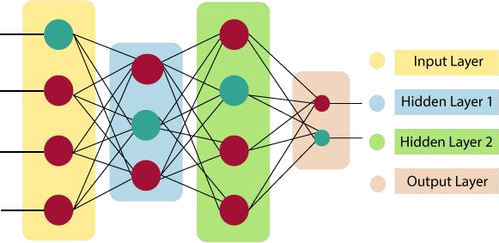

## Input Layer:

As the name suggests, it accepts inputs in several different formats provided by the programmer.

## Hidden Layer:

The hidden layer presents in-between input and output layers. It performs all the calculations to find hidden features and patterns.

## Output Layer:

The input goes through a series of transformations using the hidden layer, which finally results in output that is conveyed using this layer.

The artificial neural network takes input and computes the weighted sum of the inputs and includes a bias. This computation is represented in the form of a transfer function.



It determines the weighted total is passed as an input to an activation function to produce the output. Activation functions choose whether a node should fire or not. Only those who are fired make it to the output layer. There are distinctive activation functions available that can be applied upon the sort of task we are performing.

## Model of Artificial Neural Network

The following diagram represents the general model of ANN followed by its processing.

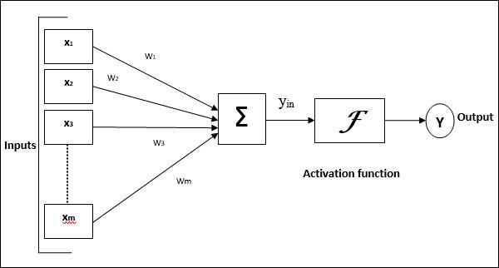

For the above general model of artificial neural network, the net input can be calculated as follows −

yin=x1.w1+x2.w2+x3.w3…xm.wm yin=x1.w1+x2.w2+x3.w3…xm.wm i.e., Net input yin=∑mixi.wi

yin=∑imxi.wi

The output can be calculated by applying the activation function over the net input.

Y=F(yin)

Output = function net input calculated

## Feed-Forward ANN:

A feed-forward network is a basic neural network consisting of an input layer, an output layer, and at least one layer of a neuron. Through assessment of its output by reviewing its input, the intensity of the network can be noticed based on group behavior of the associated neurons, and the output is decided. The primary advantage of this network is that it figures out how to evaluate and recognize input patterns.

## Advantages of Artificial Neural Network (ANN) Parallel processing capability:

Artificial neural networks have a numerical value that can perform more than one task simultaneously.

## Storing data on the entire network:

Data that is used in traditional programming is stored on the whole network, not on a database. The disappearance of a couple of pieces of data in one place doesn't prevent the network from working.

## Capability to work with incomplete knowledge:

After ANN training, the information may produce output even with inadequate data. The loss of performance here relies upon the significance of missing data.

## Having a memory distribution:

For ANN is to be able to adapt, it is important to determine the examples and to encourage the network according to the desired output by demonstrating these examples to the network. The succession of the network is directly proportional to the chosen instances, and if the event can't appear to the network in all its aspects, it can produce false output.

## Having fault tolerance:

Extortion of one or more cells of ANN does not prohibit it from generating output, and this feature makes the network fault-tolerance.

## Disadvantages of Artificial Neural Network:

**Assurance of proper network structure:**

There is no particular guideline for determining the structure of artificial neural networks. The appropriate network structure is accomplished through experience, trial, and error.

## Unrecognized behavior of the network:

It is the most significant issue of ANN. When ANN produces a testing solution, it does not provide insight concerning why and how. It decreases trust in the network.

## Hardware dependence:

Artificial neural networks need processors with parallel processing power, as per their structure. Therefore, the realization of the equipment is dependent.

## Difficulty of showing the issue to the network:

ANNs can work with numerical data. Problems must be converted into numerical values before being introduced to ANN. The presentation mechanism to be resolved here will directly impact the performance of the network. It relies on the user's abilities.

## The duration of the network is unknown:

The network is reduced to a specific value of the error, and this value does not give us optimum results.

# Conculsion:

Multilayer perceptrons are the most commonly used types of neural networks. Using the backpropagation algorithm for training, they can be used for a wide range of applications, from the functional approximation to prediction in various fields, such as estimating the load of a calculating system or modeling the evolution of chemical reactions of polymerization, described by complex systems of differential equations.

# Questions:

* 1. What are the 3 components of the neural network?
  2. Why is Multilayer Perceptron better than single layer?
  3. What is the use of multi-layer neural networks?
  4. What is the advantage of basis function over a multilayer feed forward neural network?
  5. Why is MLP called a universal Approximator?
  6. How many hidden layers are present in multi layer Perceptron?
  7. [What is Epoch in Machine Learning?](https://intellipaat.com/blog/interview-question/machine-learning-interview-questions/#15)